COSITOARE-TOCĂTOARE DE TIP OT CANAVARI

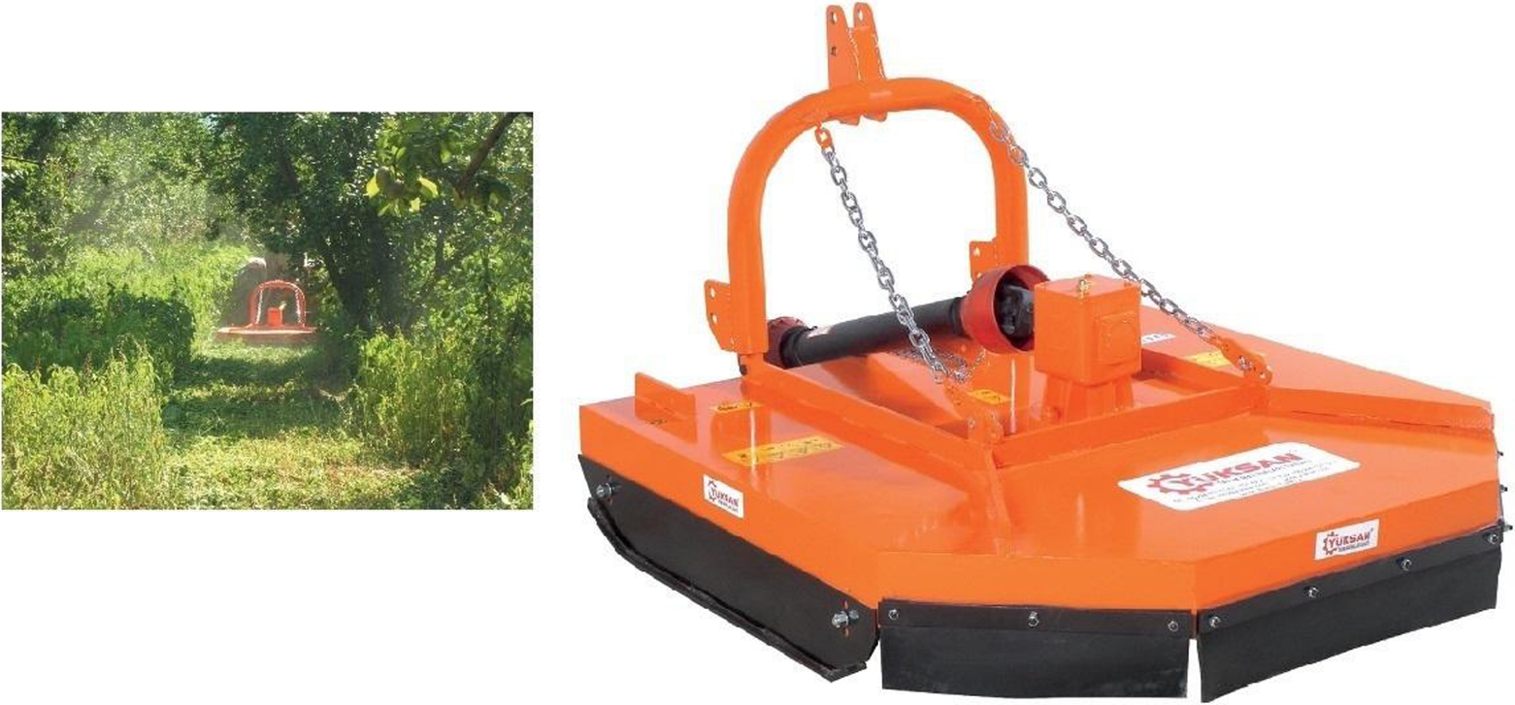

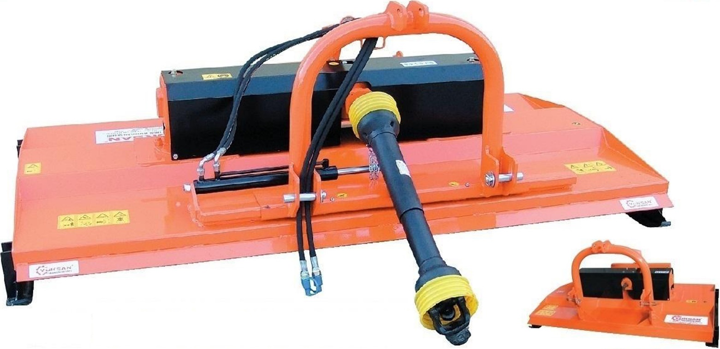

CARACTERISTICI TEHNICE:
MODEL |  |  |  |  | RPM
YOPM - 100 | 1000 | 150 | 20-30 | 50_______________50  30____________________70 | 540 | 2
YOPM - 130 | 1300 | 170 | 30-50 | 65_______________65  40____________________90 | 540 | 2
YOPM - 150 | 1500 | 185 | 30-60 | 75_______________75  50____________________100 | 540 | 2
YOPM - 180 | 1800 | 200 | 40-60 | 90_______________90  55____________________125 | 540 | 2

MODEL |  |  |  |  | RPM
YÇDOPM - 220 | 2200 | 420 | 40-60 | 110_______________110  70____________________150 | 540 | 4
YÇDOPM - 240 | 2400 | 450 | 40-60 | 110_______________130  90____________________150 | 540 | 4

