TOCĂTOARE CU DEPLASARE HIDRAULICĂ DE TIP TURBO

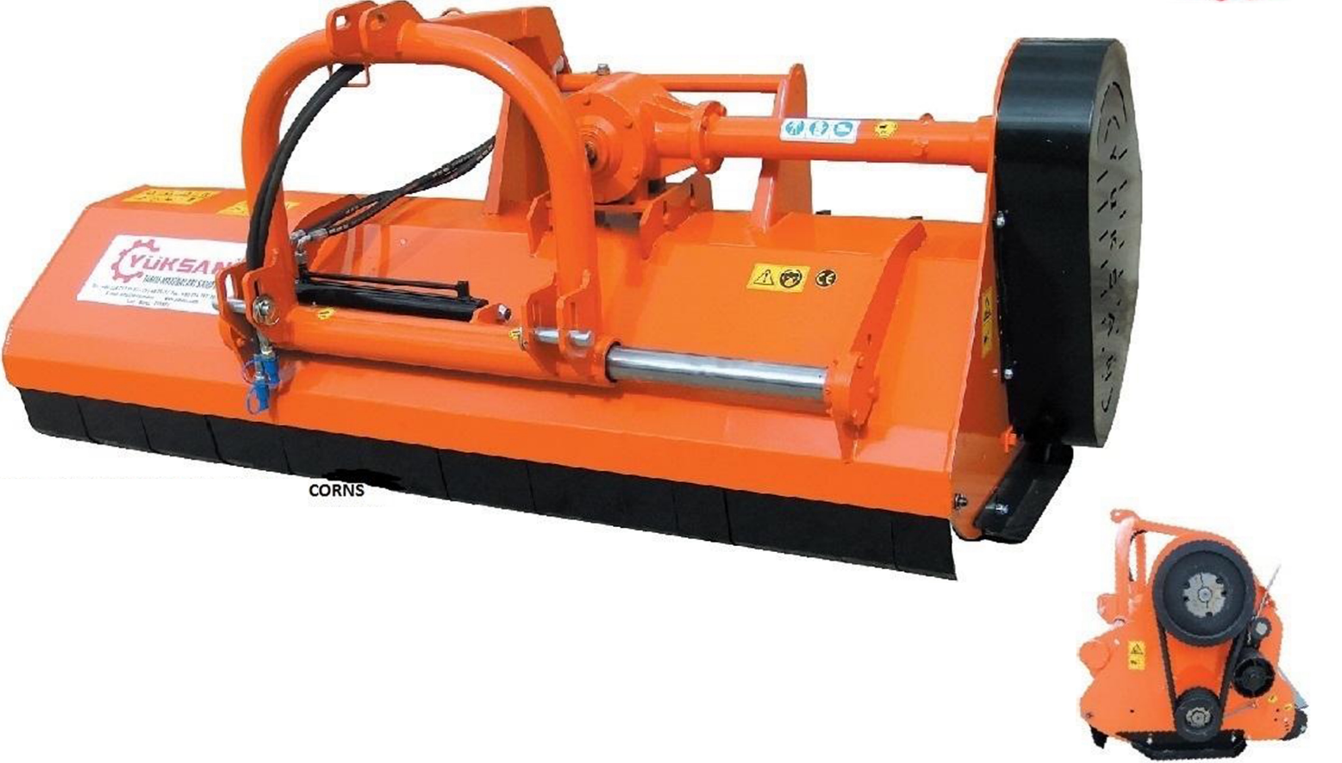

CARACTERISTICI TEHNICE:
MODEL |  |  |  |  | RPM
YHGOS - 160 | 1600 | 480 | 40-50 | 70_______________90  30____________________130 | 540 | 16
YHGOS - 180 | 1800 | 510 | 40-55 | 80_______________100  40____________________140 | 540 | 20
YHGOS - 200 | 2000 | 540 | 45-70 | 90_______________110  50____________________150 | 540 | 20
YHGOS - 220 | 2200 | 560 | 50-70 | 100_______________120  60____________________160 | 540 | 24
YHGOS - 240 | 2400 | 590 | 50-70 | 110_______________130  70____________________170 | 540 | 28

